Keynesian Macro-Economics.
Name.
Institution.
Date.

Question 1: Keynes IS-LM model.
Keynes IS-LM model which implies (investment-savings “IS” and Liquidity-money “LM”) is a macroeconomic model developed by Keynesian economists to show how the existing market for commodities “investment-savings” interacts with the money market “liquidity-money.” Keynes shows the IS and LM intersection by use of graph; to depict the short-run equilibrium amid the interests rates and output, which is determined by the point of intersection between IS and LM curves (Brady, 2017). In other words, Keynes uses the IS-LM model to assess the link between the Gross Domestic Product (GDP) and interest rates. This is because the whole economy is subject to two markets, that is, money and the output, whose demand and supply features propel the economy towards an equilibrium point, also called the Keynesian cross. Also, the IS-LM interaction establishes a combination of interest rates and the total output which often determines the state of money market equilibrium.
The IS-LM model.
In the IS-LM model, the IS curve slopes downwards towards the right (has negative gradient). The assumption behind is that the actual levels of investment and consumption have a negative relation to the money interest rates, but then positive relation with the total output. The LM curve slope upwards (has positive gradient) which matches with the increase in the aggregate spending. Below is a graphical illustration of the IS-LM model:
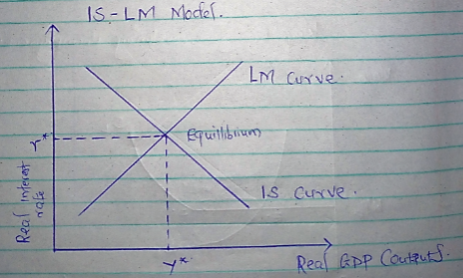
Combining the IS and LM curves yield the equilibrium interest rates and total GDP. The point of intersection of the two curves is the combination of interest rate and the real GDP, denoted by (r*, Y*). This implies that the goods market and money market are at equilibrium as shown above.
From an economic perspective, business confidence is subject to the interest rates which often triggers more investments in the economy. As such, when the autonomous spending increases, the general level of economy increases which often boosts the interest rates in the economy hence business confidence. This leads to shift in equilibrium as shown below.

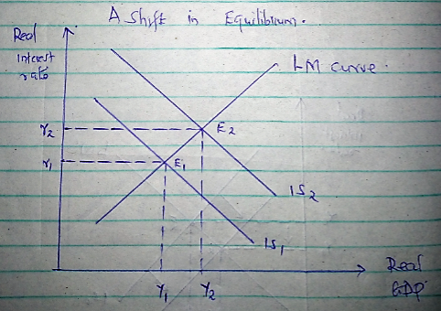
The IS curve shifts to the right meaning that businesses are investing and saving more. This leads to the shift of equilibrium along the fixed LM curve thus causing higher interest rates from r1 to r2, together with increased real GDP from Y1 to Y2.
Question 2.
According to Keynesians, involuntary unemployment refers to a situation whereby people are unable to secure or find employment at the ongoing wage rate. In other words, it is a state where an economy has surplus labor willing to work at the current real wage rate (Rognlie et al., 2017).
Involuntary unemployment occurs to a country when the real wage-price is inflexible due to money illusion and institutional reasons (Sakai, 2017). According to Keynesians, other causes of involuntary unemployment is the liquidity trap and also interest inelasticity of investments. This often reduces demand for labor regardless of the existing labor supply. This makes capitalist nations experiences growing rate of unemployment. Below is a model explanation.
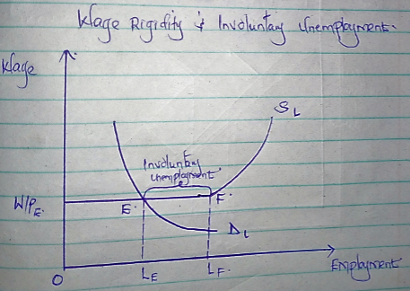
From the above diagram, Keynes labor function is perceived to be a function of money wage rate. At equilibrium, the demand for labor intersects with labor supply curve at the horizontal portion at point E which signifies underemployment equilibrium, parallel to equilibrium real wage rate (W/P) E. At the existing wage rate, LF laborers are interested in working but only LE have secured jobs. Thus the gap between LE and LF is the actual measures of involuntary unemployment caused by wage-price rigidity.
Keynes perspectives differ with classical economists in that a capitalist economy can never attain full employment. Thus, full employment condition in a country is a kind of fortune-telling coincidence, and hence all labor cannot be fully absorbed in the labor market (Kriesler&Nevile, 2016). Keynesians economists argued that for a capitalist economy to fix these challenges, the labor supply function must be a function of money wages and not real wages. On the other hand, classical arguments suggested that labor supply is subject to real wages and not money wages.

Question 3.
a). The decrease in government purchases leads to decline in country’s total GDP as shown below.
Effects of decrease in government purchasing on equilibrium GDP.
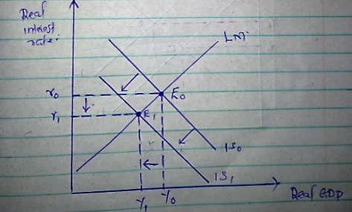
The decrease in government purchases reduces the equilibrium GDP. This is because the IS curve shifts to the left from IS0 to IS1. Also, the interest rate declines from r0 to r1. This leads to change in GDP equilibrium by (Y0 – Y1) from E0 to E1. Changes in fiscal policy do not affect the LM curve.

b). Increase in exports leads to increase in the national income of a country as shown below.
Effects of increase in exports on equilibrium GPD
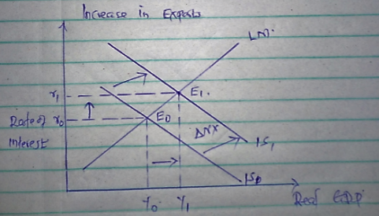
Increase in exports leads to increase in nation’s foreign exchange income. This leads to a shift in IS curve to the right per the change in the Net Export. The GDP shifts to the right from Y0 to Y1. This leads to shifts in the equilibrium of the GDP to the right from E0 to E1.

C). The equal decrease in government purchasing and taxes at the same time is contradicting fiscal policy. As such, decreasing government expenditure reduces interest rate and GDP hence shifting the IS curve to the left (Kriesler&Nevile, 2016). On the other hand, reducing tax increases consumer disposable income, increasing interest rates and GDP thus IS curve changes to the right. Combining the two policies, the impact on GDP might be positive or negative or even unfelt.
Illustration.
Equal decrease in government purchases and taxes.
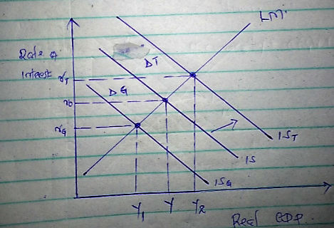

References.
Brady, M. E. (2017). On JM Keynes's Correspondence about His General Theory IS-LM Model with Harrod and Hicks on Their Interpretations of His IS-LM Model: Keynes Had No Major Objections Because IS–LM Was Created, Developed and Applied by Keynes in the General Theory in Chapter 15.
Kriesler, P., &Nevile, J. W. (2016). IS-LM and macroeconomics after Keynes. In Post-Keynesian Essays from Down Under Volume I: Essays on Keynes, Harrod and Kalecki (pp. 69-80). Palgrave Macmillan, London.
Rognlie, M., Straub, L., &Auclert, A. (2017). The Intertemporal Keynesian Cross. In 2017 Meeting Papers (No. 1587). Society for Economic Dynamics.
Sakai, Y. (2017). Involuntary Unemployment versus" Involuntary Employment": JM Keynes and Beyond. Center for Risk Research (CRR), Shiga University.

